Instructions for accessing eBooks
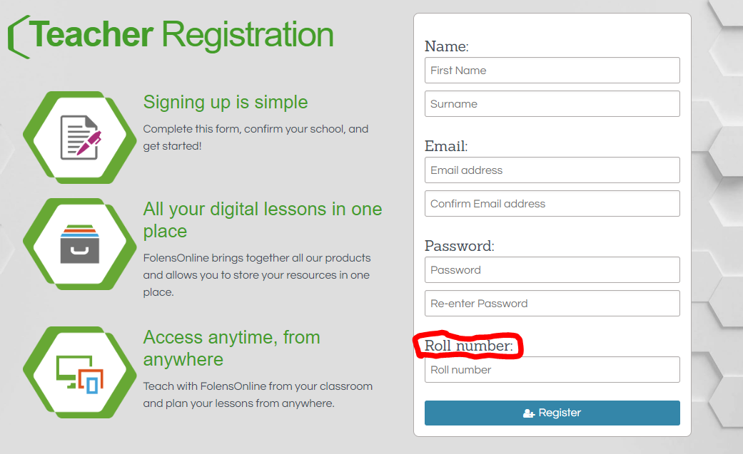
FOLENSONLINE ( Used for Fuaimeanna + Focail + Abair Liom)
- Go to www.folensonline.ie
- Click Register
- Register as a TEACHER
- Enter the details required including your email address and password.
In the roll number box enter the code Prim20. This will give you free access to all the FolensOnline eBooks.
- It will then ask you to verify your email address and you will then be asked to choose which books you require access for.
- You can then access these books easily using the username (email) and password you entered at the beginning.
Enter the Code: Prim20 in the Roll Number box to access all the FolensOnline Ebooks and activities.

CJFallon (Used for Busy at Maths, Ready to Go, Spell Well, Small World History Geography and Science)

CJFallon allow free access to their library of online ebooks at:

https://my.cjfallon.ie/dashboard/student-resources/

There is no sign up process required with CJFallon but you may be required to enter an email address when you try to access any ebook.

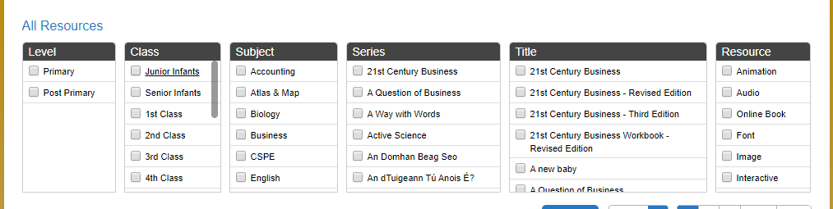
Select the level, class and subject in order to find your desired eBook easily

