Junior Infants: Week of January 25th
Hi everyone, thanks for all the engagement last week. It was great to regularly receive work from your son/ daughter. In terms of phonics please make sure it is the letter sound you/ they are using. On their booklist it was suggested to get The teach your monster to read app. If you have that downloaded you could begin at level 1- it has different activities starting with the letter s and it introduces new sounds as they continue to play the game. A great way to reinforce the letter sounds.
Please email me at cmurphy@lachteen.ie if you have any queries.
Monday
Maths | - Writing the number 5 in their scrapbook. As they write we say the rhyme: ‘short neck, belly fat, number 5 wears a hat’.  - Capacity: watch video  - Busy at maths: pg. 96 | - Video on
Literacy | - Syllables  - Rhyming | - video on
News time | Pupils can share a photo/ record a voice note/ record a video on seesaw to tell me some of their news (if they wish). Maybe it’s what they did for the weekend, maybe something they have enjoyed playing with recently etc.
Play time | Play time is one of our favourite times in school so have fun

Tuesday
Maths | Capacity – hands on activities- use rice, beans, water, sand, lego etc. (whatever you have) Give them time to explore filling up cups, bowls, jugs with these different materials- discuss which is full, which is empty, which is half full etc.
Phonics | - The letter i sound- listen to the song  https://www.youtube.com/watch?v=QL7w-PAQUb8  - Listen to the ‘i’ story- see if you can hear some ‘i’ words  - Sounds like phonics: pg. 10 (letter i) | - video on  - video on
Letter formation | letter o (same as last week)- Just handwriting pg. 8  As they are writing remind them to say ‘make a c and do not stop’.
Fine motor | Theraputty- making a wiggly worms, stacking the wiggly worms. Making a big ball, making 3 small balls- pressing each button/ ball, make a smiley face with the balls, stacking the balls. | - Video on
Play time | Play time is one of our favourite times in school so have fun

Wednesday:
Maths | - 5 Frame: they will need their 5 frame (laminated page with 5 boxes) and counters in their small ziplock bags. | - video on
Phonics | - https://slp.cjfallon.ie/  - Click Sounds like Phonics A  - Click unit 2 the market  - Click i and complete the various activities on that page.  - Sounds like phonics: pg. 11 (letter i)  - www.starfall.com – letter i- follow the link  https://www.starfall.com/h/abcs/letter-i/? | video on
Fine motor | - using clothes pegs and a plastic lid/ basket/ cup/ box put the clothes around the edge. They should be using their ‘baby shark’ (thumb and peter pointer) fingers to squeeze the clothes pegs.  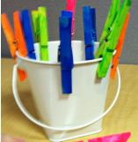
Play time

Thursday:
Maths | - Capacity: Busy at maths: pg 97 | video on
Phonics | - The letter p sound- listen to the song  https://www.youtube.com/watch?v=CDo6o9Wmn60  - Listen to the ‘p’ story- see if you can hear some ‘p’ words  - Sounds like phonics: pg. 26 (letter p) | video on
Letter formation | - letter a- practise writing this letter in their scrapbook. As they are writing the letter we say ‘make a ‘c’, up, down and a kick’. | - video on
Play time

Friday:
Maths | - 5 Frame: they will need their 5 frame (laminated page with 5 boxes) and counters in their small ziplock bags.  - Maths game: link on | Video on
Phonics | - https://slp.cjfallon.ie/  - Click Sounds like Phonics A  - Click unit 2 the market  - Click p and complete the various activities on that page.  - Sounds like phonics: pg. 27 (letter p)  - Click the link and have a look at the letter ‘p’  https://www.starfall.com/h/abcs/letter-p/? | Video on
Fine motor | Scissors cutting- you will need playdough and scissors. Get your child to roll their playdough into a snake. Using their scissors they can cut the snake into smaller little snakes. | Video on
Play time

Other suggested activities for over the course of the week- these are optional.
SESE | Learn about Black bears by watching this video https://www.youtube.com/watch?v=5jyFpgIWzsE
Story time | Brown Bear Brown Bear What do you See? (read and signed by me) Video on
Gaeilge | Video on
PE | Movement ideas:  - Do a bear walk.  - Juggle like a monkey  - Dance like a clown  - Tiptoe across the tightrope  - Roar like a lion  - Stomp like an elephant  - Wiggle like a seal  - Lift your arms like a strong person  - Swing your trunk like an elephant  - Jump like a tiger  - Bow like the ringmaster  - Shoot like a cannon  - Cheer like the audience  - Wave your wand like a magician
Art | Step by step drawing of a teddy bear  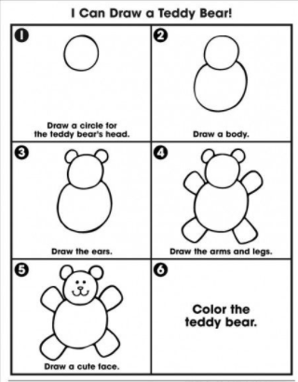
Music | Song singing  Goldilocks and the three bears https://www.youtube.com/watch?v=UaulRHrJGeU  The bear went over the mountain https://www.youtube.com/watch?v=KCLjdL8g-8s
Rhyme | A little brown bear  Went in search of some honey.  Isn’t it funny,  A bear wanting honey  He sniffed at the breeze,  And would you believe it,  Even climbed some trees.

