Junior Infants: Week of January 18th
Hi everyone, thanks for all the engagement last week. Please check seesaw daily as there will be explanation videos uploaded each morning at 8.30. You can complete them at a time when suits you and your son/ daughter. As described in email each day they will have playtime maths, literacy/ phonics, letter formation or fine motor skills activities every day. At the bottom of this word document you will also find additional work that you can choose to complete- this is optional. Please email me at cmurphy@lachteen.ie if you have any queries.
Monday
Maths | - Writing the number 1 in their scrapbook. As they write we say ‘start at the top and down we run, that’s the way we make a 1’.  - Busy at maths: pg. 53- counting sets of 3 | - Video on
Phonics | - Revise the letter a sound- listen to the song  https://www.youtube.com/watch?v=RSj3XeJXfnc  - Listen to the ‘a’ story- see if you can hear some ‘a’ words  - Sounds like phonics: pg. 4 (letter a) | - video on  - video on
Play time | Play time is one of our favourite times in school so have fun

Tuesday
Maths | Play the following game where you need to feed teddy some cakes.  https://www.topmarks.co.uk/learning-to-count/teddy-numbers  watch the following video about number 3 https://www.watchkin.com/7db279cc39  Watch the following video about number 3 in numberblocks  https://www.watchkin.com/dcbf333f25 | - Links to videos on
Letter formation | letter c (same as last week)- Just handwriting pg. 6 (complete as much of this page as you feel they are able for. The focus is very much on them writing the letter correctly- starting at the top).  Remind them to say ‘start at the top, go around and stop’.
Fine motor | Theraputty- rolling it into a ball, rolling into a snake, pinching it with index finger and thumb. flattening it into a pancake. Pressing each finger on each hand into the pancake. Hide 3 counters in the theraputty and they or someone else has to find it. | - Video on
Play time | Play time is one of our favourite times in school so have fun

Wednesday:
Maths | - Busy at maths: pg. 54  - Revising 1, 2, 3- recognising numicon shapes/ digits when shown.  - Shown sets of objects of either 1, 2 or 3 and say how many objects they can see. | - video on
Phonics | - https://slp.cjfallon.ie/  - Click Sounds like Phonics A  - Click unit 1 the funfair  - Click a and complete the various activities on that page.  - Sounds like phonics: pg. 5 (letter a)  - www.starfall.com – letter a- follow the link  https://www.starfall.com/h/abcs/letter-a/? | video on
Fine motor | - Peg boards
Play time

Thursday:
Maths | - Number 4- writing the number in their scrapbook- we say ‘down and over, down some more, that’s the way we make a 4’.  - Maths game- follow the link https://wordwall.net/resource/9417158 | video on
Phonics | - Revise the letter t sound- listen to the song  https://www.youtube.com/watch?v=t6Pn2zVz3eo  - Listen to the ‘t’ story- see if you can hear some ‘t’ words  - Sounds like phonics: pg. 2 (letter t) | video on
Letter formation | - letter o- practise writing this letter in their scrapbook. As they are writing the letter we say ‘make a c and do not stop’. | - video on
Play time

Friday:
Maths | - Maths game: https://wordwall.net/resource/9417158
Phonics | - https://slp.cjfallon.ie/  - Click Sounds like Phonics A  - Click unit 1 the funfair  - Click t and complete the various activities on that page.  - Sounds like phonics: pg. 3 (letter t)  - Click the link and have a look at the letter ‘t’  https://www.starfall.com/h/abcs/letter-t/? | Video on
Fine motor | Scissors cutting- paper and scissors to snip. Your child uses a scissors make some snips along one side- they don’t want to cut all the way through, just making snips.  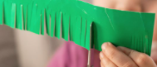
Play time

Other suggested activities for over the course of the week- these are optional.
SESE | Explore with me pg. 23- the Penguin  Video on  Click this link to watch a song with informational facts about penguins. https://www.youtube.com/watch?ifyouwannafindpenguins
Gaeilge | Video on
PE | Penguin dance https://www.watchkin.com/01b98f6855
Art | Penguin step by step drawing.  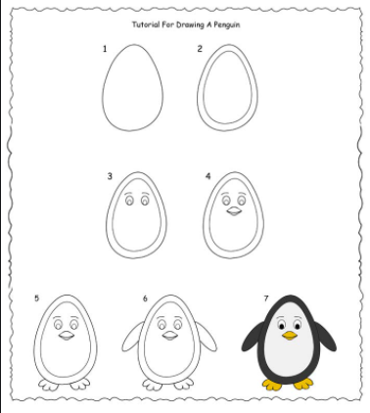
Music | Song singing:  Did you ever see a penguin https://www.watchkin.com/8f98d76a33
Rhyme | There’s a penguin on the table,  There’s a penguin on the chair.  There’s a penguin eating popcorn  There are penguins everywhere.  There’s a penguin on the ladder.  There’s a penguin on the ground.  There’s a penguin on the rooftop.  There are penguins all around.

