Junior Infants: Week of January 11th
Please check seesaw daily as there will be explanation videos uploaded each morning at 8.30. You can complete them at a time when suits you and your son/ daughter. As described in email each day they will have playtime maths, literacy/ phonics, letter formation or fine motor skills activities every day. At the bottom of this word document you will also find additional work that you can choose to complete- this is optional.

Tuesday
Maths | - Maths: find objects and create sets of 1 and 2. Send photo on seesaw of their sets. | - Video on
Phonics | - Revise the letter s sound- listen to the song https://www.youtube.com/watch?v=APts0BQi0LA  - Listen to the ‘s’ story- see if you can hear some ‘s’ words  - Sounds like phonics: pg. 6 (letter s)  - www.starfall.com – letter s- follow the link https://www.starfall.com/h/abcs/letter-s/? | - video on  - video on
Play time | Play time is one of our favourite times in school so have fun

Wednesday:
Maths | - Busy at maths: pg. 46- revising 1 and 2 | - video on
Phonics | - https://slp.cjfallon.ie/  - Click Sounds like Phonics A  - Click unit 1 the funfair  - Click s and complete the various activities on that page.
Fine motor | - create any shape/ pattern they wish using their peg boards.
Play time

Thursday:
Maths | - Maths: find objects and create sets of 3. | - Send photo on
Phonics | - Revise the letter s sound.  - Can you find ‘s’ words- see picture below  - Read the ‘s’ story by clicking the link and listening out for ‘s’ words. | https://drive.google.com/file/d/1-Nc73kcLLswB84KBTLiNM3_CfvS1eaUw/view?usp=sharing
Letter formation | - letter c- practise writing this letter in their scrapbook. As they are writing the letter we say ‘start at the top, go around and stop’. | - video on
Play time

Friday:
Maths | - Busy at maths: pg. 51- focus on sets of 3. | video on
Phonics | - Sounds like phonics: pg. 7 (letter s) | Video on
Fine motor | - Playdough disco- click the link and have fun doing the playdough disco https://www.youtube.com/watch?v=zJQ2CaA7E50
Play time

Other suggested activities for over the course of the week- these are optional.

SESE | Explore with me: pg. 26- old and new toys  Click the link to look at toys from over the years https://watchkin.com/b10ef0020d
PE | Cosmic yoga- click the following link https://www.youtube.com/cosmickidslisteningden
Art | Make a snowman by cutting out some circles. Be careful when using a scissors  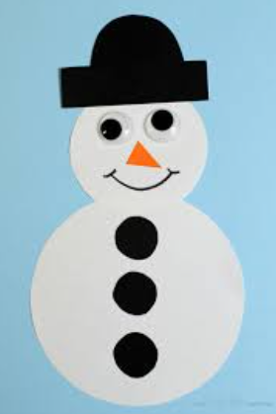
Music | Song singing:  Do you wanna build a snowman? https://www.youtube.com/doyouwannabuild  Hey Mr. Snowman https://watchkin.com/0f0ff5b5b3

Find ‘s’ pictures
