Junior Infants: Week of February 8th
Hi everyone, once thanks for all the work being done at home. We will have our zoom call on Monday morning at 9.30- hopefully lots of you will be able to join us. Our theme is ‘Show and tell’- they can bring a toy/ art work/ pet etc and tell us about it. Any queries please contact me at cmurphy@lachteen.ie . Looking forward to seeing your son/ daughter on Monday. Thanks again.
Monday
Zoom | Zoom call- show and tell
Literacy | Revision of the letters s,a,t,i,p,n  Listen and blend –og words.  - The letter e sound- listen to the song  - Listen to the ‘e’ story- see if you can hear some ‘e’ words  Sounds like phonics: pg. 30 (letter e) | video on  video on
Fine motor skills | Drawing a picture of anything they would like to draw.
Play time

Tuesday
Fine motor skills | Theraputty | - video on
Phonics | - https://slp.cjfallon.ie/  - Click Sounds like Phonics A  - Click unit 2 the market  - Click e and complete the various activities on that page.  - Sounds like phonics: pg 31. (letter e) | - video on  - video on
Maths | Busy at maths- pg. 58 | video on
Play time

Wednesday:
Maths | - Busy at maths: pg. 59 | - video on
Phonics | - Game on seesaw
Story time | Listen to the story on seesaw- they could draw a picture of their favourite part of the story. | video on
Play time

Thursday:
Maths | - Matching numeral cards with towers of cubes-  - Maths games- link on seesaw | video on
Phonics | - The letter h sound- listen to the song  - Listen to the ‘h’ story- see if you can hear some ‘h’ words  - Sounds like phonics: pg. 20 (letter h)
Letter formation | Same as last week-  - Revise letters c, o, a, d  c- around and stop  o- make a c and do not stop  a-make a c, up, down and a kick  d- make a c, up up, down and a kick.  You can practise revising these using pencil/ crayon on paper. You could also create a writing tray- bascially a baking tray and put in some sprinkles/ rice etc. Using a pencil, finger, paintbrush they can practise ‘writing’ the letter in the sprinkles/ rice. Again it is really important that they are forming ‘c’ correctly as he leads into o, a, d, g, q, s. If you have chalk you can practise outside on the footpath. | 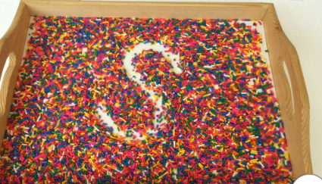  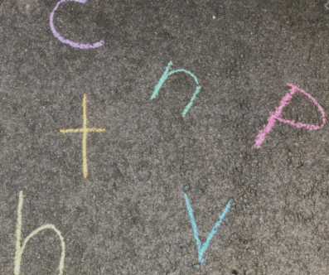
Play time

Friday:
Phonics | - https://slp.cjfallon.ie/  - Click Sounds like Phonics A  - Click unit 1 the funfair  - Click h and complete the various activities on that page.  - Sounds like phonics: pg. (letter h) | Video on
Five for Five Friday | Have fun | Video on
Play time

Other suggested activities for over the course of the week- these are optional.
SESE | Valentine’s Day Video on
Gaeilge | Video on
PE | Focus on the skill of side stepping  - Find some lines and practise side stepping along them.  - Talk about the difference between running and side stepping with a grown-up.  - At home, make a maze using lines of socks, lego bricks, books, scarves or towels to form the walls of the maze. Practise side stepping through the maze.  - Practise side stepping at home holding hands with a family member. 8. At home, practise side stepping up and down your hall, driveway, kitchen or garden.  - Invite a grown-up to watch you and show them how to side step correctly.  - Practise side stepping leading with the right foot in the yard.  - Practise side stepping leading with the left foot in the yard.
Art | 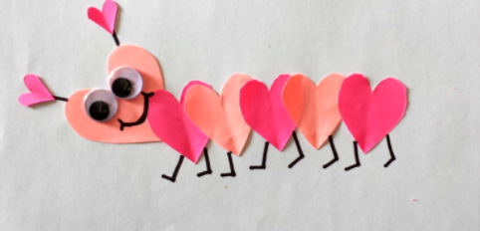
Music | Song singing:  Skidamrink I love you https://www.youtube.com/watch?v=ug1pI-Ephns&feature=youtu.be  The heart song https://www.youtube.com/watch?v=kgAx_sQ0mqE&feature=youtu.be

