Junior Infants: Week of February 22nd
Hi everyone, hope you had a nice weekend. We will have our zoom call on Monday morning at 9.30- hopefully lots of you will be able to join us. Just a reminder that our theme is show and tell this week. Any queries please contact me at cmurphy@lachteen.ie . Looking forward to seeing your son/ daughter on Monday. Thanks again.
Monday
Zoom | Zoom call- show and tell
Literacy | - Blending video- ‘en’ words  - The letter m sound- listen to the song  - Listen to the ‘m’ story- see if you can hear some ‘m’ words  Sounds like phonics: pg. 8 (letter m) | video on  video on
Play time

Tuesday
Lette formation | Letter ‘r’- our rhyme is ‘down, up and draw an arm’. Practise writing the letter r in their scrapbook. | video on
Phonics | - https://slp.cjfallon.ie/  - Click Sounds like Phonics A  - Click unit 1 The Funfair  - Click m and complete the various activities on that page.  - Sounds like phonics: pg. 9 (letter m) | - video on
Maths | Busy at maths- pg. 73 | video on
Play time

Wednesday:
Maths | - Busy at maths: pg. 74 | - video on
Phonics | - Game on seesaw  - Blending video on seesaw
Fine motor skills | Theraputty | video on
Play time

Thursday
Maths | - Busy at maths: pg. 71  - Maths game- link on seesaw | - video on
Phonics | - The letter d sound- listen to the song  - Listen to the ‘d’ story- see if you can hear some ‘d’ words  Sounds like phonics: pg. 62 (letter d)
Letter formation | Do pg. 24 in their Just handwriting book- letter r.
Play time

Friday
Phonics | - https://slp.cjfallon.ie/  - Click Sounds like Phonics A  - Click unit 4 the zoo  - Click d and complete the various activities on that page.  - Sounds like phonics: pg 63 (letter d)
Five Star Friday

Other suggested activities for over the course of the week- these are optional.
Storytime | Spring is here https://youtu.be/2gBL7I1Bm8E  When spring comes https://youtu.be/-35AX3K5tCs
Gaeilge | Video on seesaw- an phicnic –  Foclóir- tart, ocras, ag ithe, ag ól, ciséan, ceapaire, uachtar reoite, oráiste, uisce  Do abair liom pages 62/ 63
SESE | On a nice day see if you can go on a spring walk with a grown up- look out for signs of spring. They can do pg. 37 in Explore with me. Watch the video on seesaw about spring
Art | Draw a picture of somethings you saw on your spring walk.  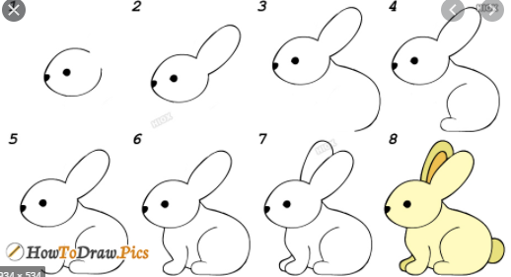
Music | Song singing:  Spring time https://youtu.be/A16Cu6Ic1pA  Springtime dance https://youtu.be/udrIY0nts-E

