Junior Infants: Week of February 15th
Hi everyone, we will have our zoom call on Monday morning at 9.30- hopefully lots of you will be able to join us. Please have theraputty ready for our zoom call Any queries please contact me at cmurphy@lachteen.ie . Looking forward to seeing your son/ daughter on Monday. Thanks again.
Monday
Zoom | Zoom call- bring theraputty
Literacy | - The letter r sound- listen to the song  - Listen to the ‘r’ story- see if you can hear some ‘r’ words  Sounds like phonics: pg. 40 (letter r) | video on  video on
Maths | Making sets of 4.  Make sets of 4 and send a photo on seesaw | video on
Play time

Tuesday
Story time | Listen to the story on seesaw- they could draw a picture of their favourite part of the story. | video on
Phonics | - https://slp.cjfallon.ie/  - Click Sounds like Phonics A  - Click unit 3 the toy shop  - Click e and complete the various activities on that page.  - Sounds like phonics: pg 41 (letter r) | - video on  - video on
Maths | Busy at maths- pg. 70 | video on
Play time

Wednesday:
Maths | - Busy at maths: pg. 71 | - video on
Phonics | - Game on seesaw
Fine motor skills | Scissors cutting with playdoug. Roll the playdough into a sausage shape and use the scissor to cut the sausages into smaller sausages. | 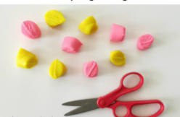
Play time

Other suggested activities for over the course of the week- these are optional.
Oral language | Discuss the vocabulary on the poster and how you make pancakes.  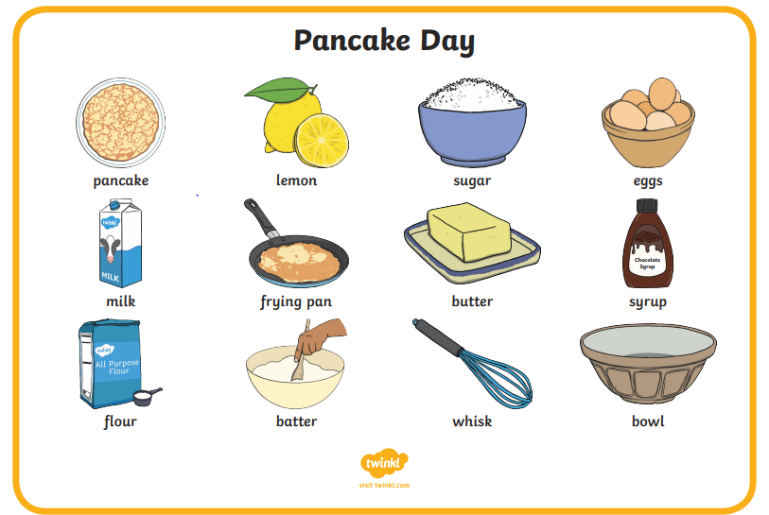
Story | Video on  https://youtu.be/MjKUEJBpA4s
Art | Draw and colour in your own pancake with your favourite toppings.
Music | Song singing:  Pancake party https://youtu.be/XDSDaFhOuo4  Pancake song and movement break https://youtu.be/vPccTY3sph4

