Junior Infants: Week of February 1st
Hi everyone, once thanks for all the work being done at home. Monday morning we are getting the week off to a great start with our zoom call- hopefully lots of you will be able to make it. If you have not received the link for the zoom please contact me at cmurphy@lachteen.ie . Looking forward to seeing your son/ daughter on Monday and don’t forget their teddy bear. Thanks again.
Monday
Zoom | Zoom call- please bring a teddy bear :)
Literacy | Rhyming/ syllables/ revision of the letter p  Click the link on seesaw to play the game | video on
Maths | Busy at maths: pg. 98- empty/ full | video on
Play time

Tuesday
Fine motor skills | Theraputty | - video on
Phonics | - The letter n sound- listen to the song  https://www.watchkin.com/49da7ad3ef  - Listen to the ‘n’ story- see if you can hear some ‘n’ words  - Sounds like phonics: pg. 44 (letter n) | - video on  - video on
News time | Pupils can share a photo/ record a voice note/ record a video on seesaw to tell me some of their news (if they wish). Maybe it’s what they did for the weekend, maybe something they have enjoyed playing with recently, something they watched on tv, something about their pet etc.
Literacy | Introducing blending – as we are learning our letter sounds we are going to begin putting these together to start reading some 2/ 3 letter words e.g. sat, it etc. Initially we are going to concentrate on listening to the sounds and seeing if they can blend them together to make the word. The video on seesaw will explain more on this. | video on
Play time

Wednesday:
Maths | - Busy at maths: pg. 56- counting sets of 1, 2, 3 | - video on
Phonics | - https://slp.cjfallon.ie/  - Click Sounds like Phonics A  - Click unit 2 the market  - Click i and complete the various activities on that page.  - Sounds like phonics: pg. 45 (letter n)  - www.starfall.com – letter n- follow the link | video on
Letter formation | letter d- the rhyme is ‘make a c, up up, down and a kick’.  As they are writing remind them to say this rhyme aloud. Practise in their scrapbook | video on
Story time | Listen to the story on seesaw- they could draw a picture of their favourite part of the story. | video on
Play time

Thursday:
Maths | - Busy at maths: pg. 57  - Maths games- link on seesaw
Phonics | - The letter c sound- listen to the song  https://youtu.be/-ZxaDdJpxns  - Listen to the ‘c’ story- see if you can hear some ‘c’ words  - Sounds like phonics: pg. 20 (letter c) | video on
Letter formation | - Revise letters c, o, a, d  c- around and stop  o- make a c and do not stop  a-make a c, up, down and a kick  d- make a c, up up, down and a kick.  You can practise revising these using pencil/ crayon on paper. You could also create a writing tray- bascially a baking tray and put in some sprinkles/ rice etc. Using a pencil, finger, paintbrush they can practise ‘writing’ the letter in the sprinkles/ rice. Again it is really important that they are forming ‘c’ correctly as he leads into o, a, d, g, q, s. If you have chalk you can practise outside on the footpath. | 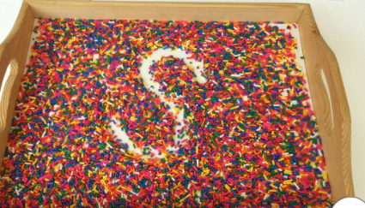  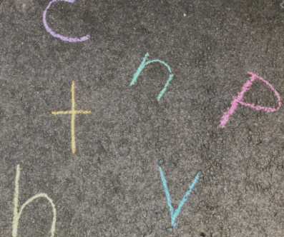
Play time

Friday:
Phonics | - https://slp.cjfallon.ie/  - Click Sounds like Phonics A  - Click unit 2 the market  - Click p and complete the various activities on that page.  - Sounds like phonics: pg. 21 (letter c) | Video on
Fine motor | ‘I like to …’ playdough song- they can use playdough or theraputty  https://youtu.be/BOLR3pQt8zg | Video on
Play time

Other suggested activities for over the course of the week- these are optional.
SESE | St Brigid Video on
Gaeilge | Video on
PE | Focus on the skill of hopping  - Play music at home and practise hopping to the beat.  - Imagine you are living in a jungle. Try hopping around your house or garden like this.  - Investigate how many hops it takes to get from the school gate to the school door.  - Practise hopping with a family member at home. Figure out how many hops you can do on one leg without stopping.  - Practise hopping on your other leg. Figure out how many hops you can do on this leg without stopping.  - 6. Ask a grown-up to help you draw a hopscotch grid using chalk and show them how to play the game. 7. Make up your own hopping game.
Art | Step by step flower drawing  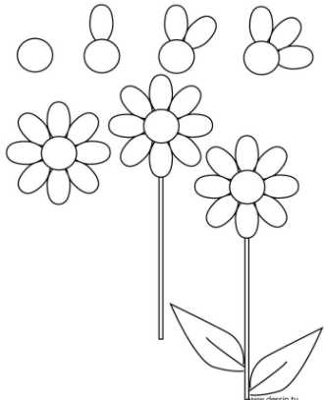
Music | Song singing:  Spring is here https://youtu.be/DobrRgD5aOU

