Book link | QR Codes |  | Book Link | QR Codes
Busy at Maths 2nd Class – Click here | 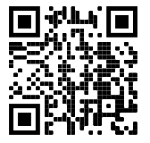 |  | Ready to Go! 3rd Class– Click here | 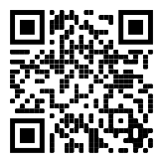
Busy at Maths 3rd Class - Click here | 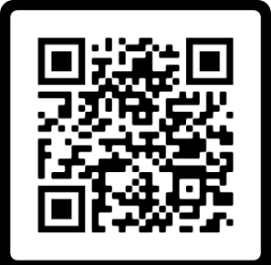 |  | Small World History 3rd Class  Click here | 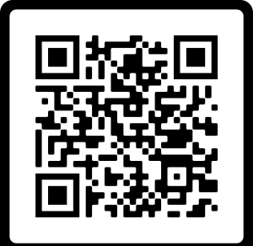
Abair Liom 3rd Class  Book – Click here  Resources – Click here | 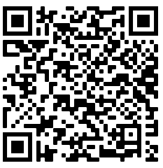 |  | Small World Geography + Science 3rd Class  Click here | 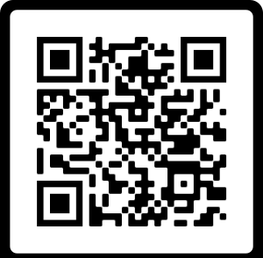

Spell Well 3rd Class -Click here | 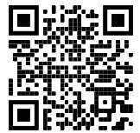 |  | Spell Well 2nd class – Click here | 